**RUSA Bill 15F21-[...]**

**Authors:** Evan M. Feldman, *Allocations Board Chair*

**Sponsors:** Allocations Board

**BILL TO AUTHORIZE SPRING 2022 FUNDING ALLOCATION**

***Whereas,*** the Rutgers University Student Assembly is charged with the duty of providing a means for and promoting student involvement and awareness within the University and the community at large; and

***Whereas,*** the mission of the RUSA Allocations Board is to promote and support diversity of programming made available to all Rutgers University Students through fair and efficient distribution of the Student Activity Fee; and

***Whereas,*** the RUSA Allocations Board is responsible for the allocation of Student Fee money to recognized Rutgers University student organizations on a semesterly basis; and

***Whereas,*** the Spring 2022 Budget Requests for recognized RUSA-funded organizations were open from Monday, September 20th at 12 AM to an initial deadline of Friday, October 29th at 11:59 PM for budget submissions, and an extension for submissions was provided until Monday, November 1st at 7:15 PM; and

***Whereas,*** Budget Help Nights were held on Monday, October 4th, Wednesday, October 6th, Monday, October 11th, and Wednesday, October 13th, from 7 - 9 PM to provide direct assistance to student organizations on budget applications; and

***Whereas,*** Spring 2022 Budget Requests, relevant deadlines, and Budget Help Nights were advertised through Officer Listservs, all Allocations social media outlets, GetInvolved, and through direct emails to student organization officers; and

***Whereas,*** during the submission period, 317 applications were received, and a total of 307 non-duplicate requests were processed for review; and

***Whereas,*** the Allocations Board met on Friday, November 5th from 5 - 9:30 PM and Saturday, November 6th from 12 - 10 PM in the Student Activities Center to review budget requests, remove unfundable items, and to apply the proper caps to each request; and

***Whereas,*** remote reviews were also conducted by groups outside of the allotted hours at the Student Activities Center on Friday and Saturday evenings, and remote work was conducted on Sunday to finalize funding numbers for all clubs and to derive a cut; and

***Whereas,*** on Monday, November 8th at the Allocations Board’s weekly Appeals Meeting, the final funding amount for all clubs and cut was approved by the Allocations Board; and

***Whereas***, the Allocations Board allocates $718,696.43 to 307 student organizations, which represents an 8.2% increase from the last in-person Spring semester in 2020; and

***Whereas***, the cut applied to all clubs is 30%, which represents a 3% decrease from the cut applied to Fall 2021 funding, and a departure from the 36.68% average cut since Fall 2016; and

***Whereas***, these funding increases are made possible by the surplus of funds brought about by COVID-19 takebacks and virtual semesters, and are increases that are sustainable for semesters to come; and

***Whereas***, the RUSA Constitution Art. VI requires approval by the Assembly for semesterly funding allocations; therefore

***Be it Hereby Enacted***, that RUSA approves the Spring 2022 allocations for those registered student groups that applied by the due dates and are outlines in the spreadsheet below; and

***Be it Hereby Resolved***, that RUSA approves the allocation of a total of $718,696.43 to 307 registered student organizations at Rutgers University ⎯ New Brunswick/Piscataway Campus using Student Activities Fee funds.

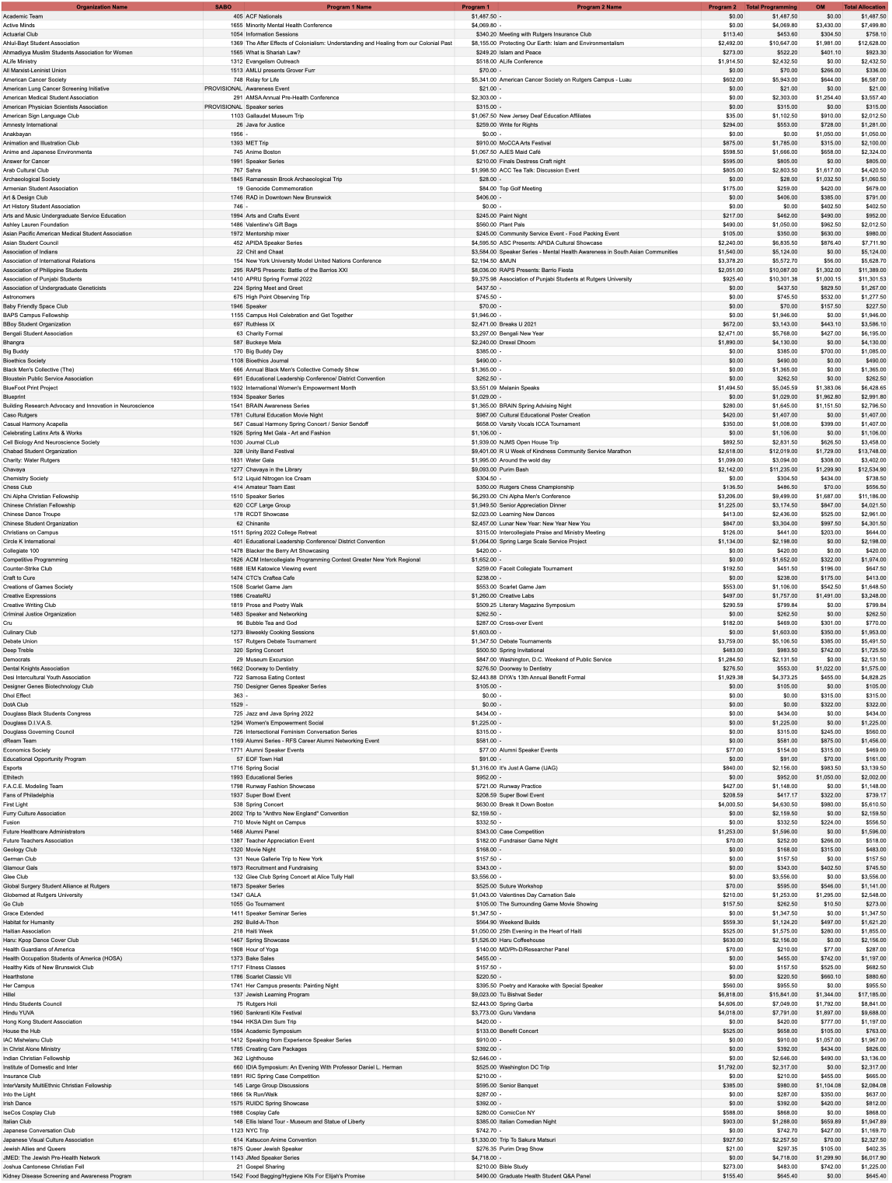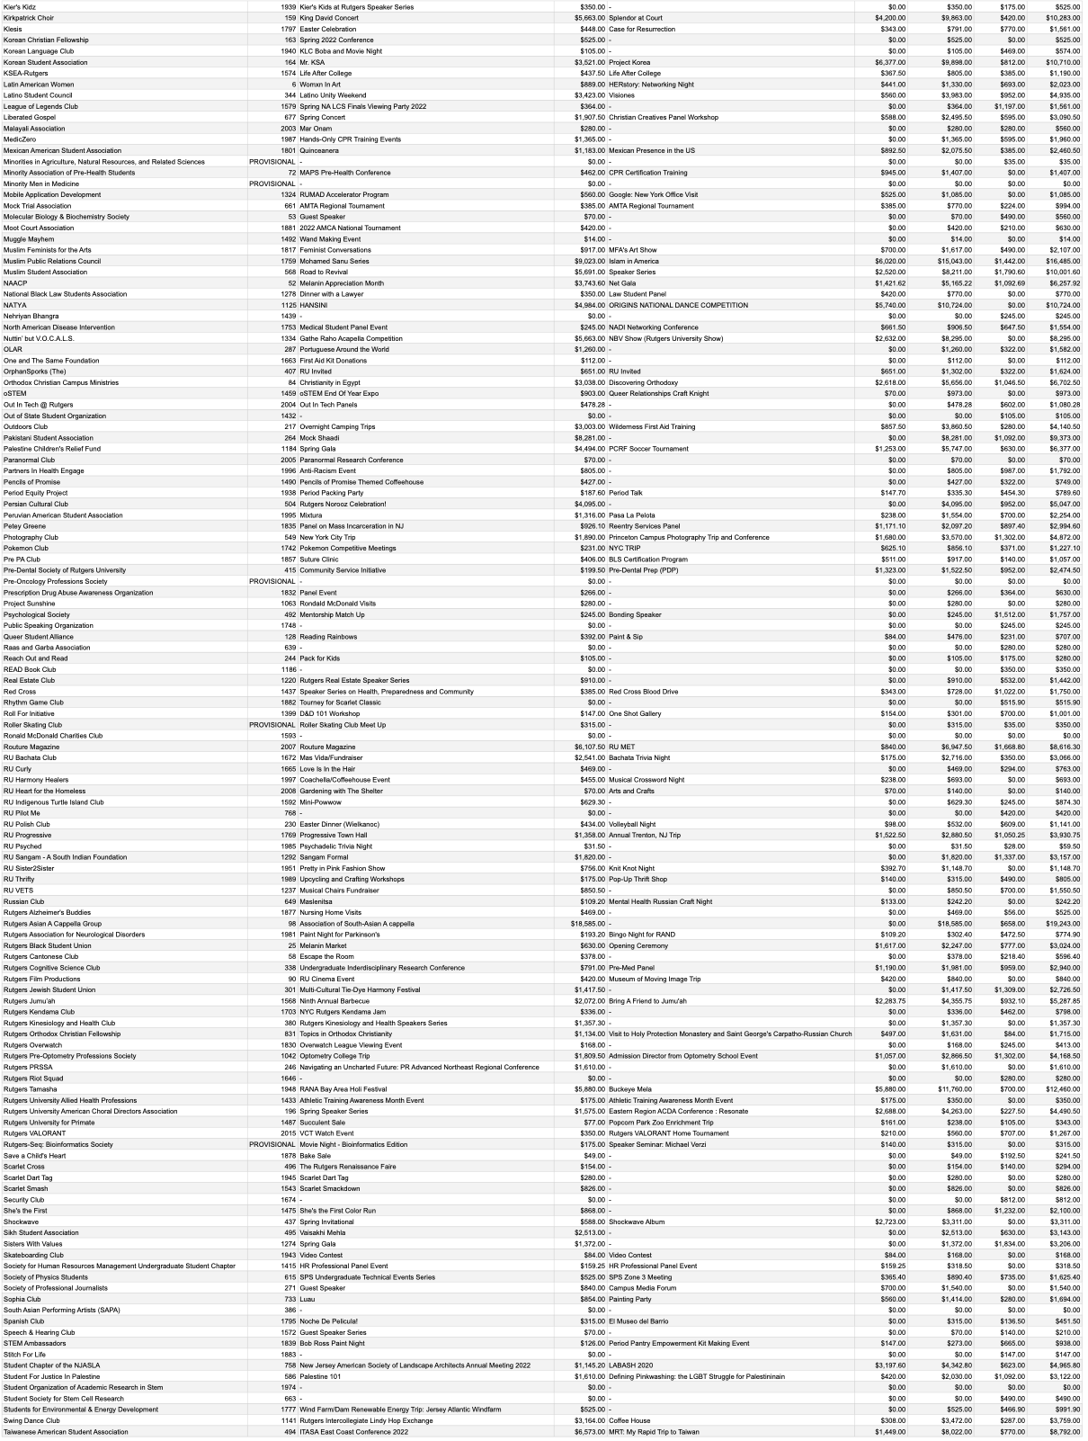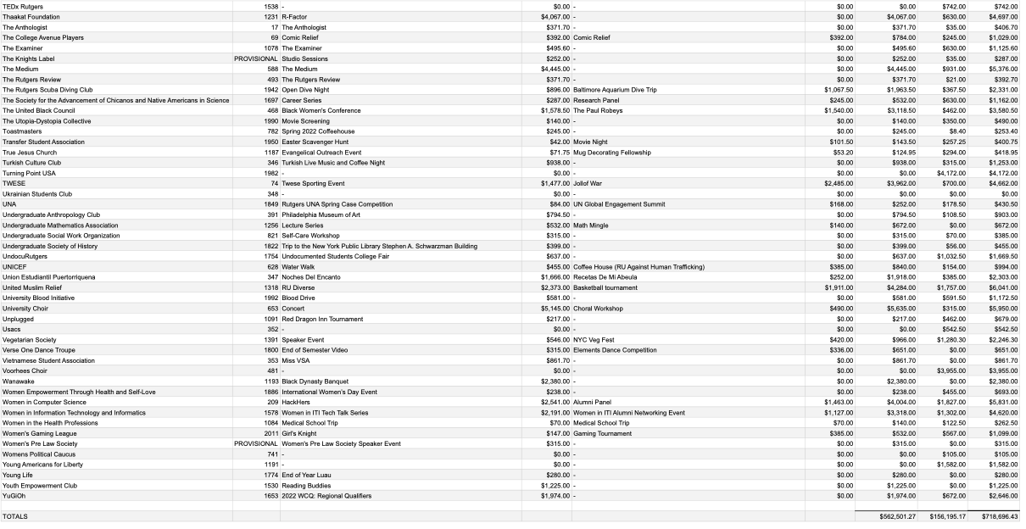

**Dates.**

## 

## Allocations Board Sponsorship

Introduced to the Allocations Board 08 November 2021

Passed by the Allocations Board 08 November 2021

Voted: Unanimous consent

## 

## Review by Executive Committee

Introduced to the Executive Committee 14 November 2021

Approved for floor by the Executive Board xx November 2021

## Floor of the Assembly

Introduced to the Assembly xx November 2021

Passed by the Assembly xx November 2021

Voted: ## yays, ## nays, ## abstains, ## presents